<https://mvnrepository.com/search?q=gson>

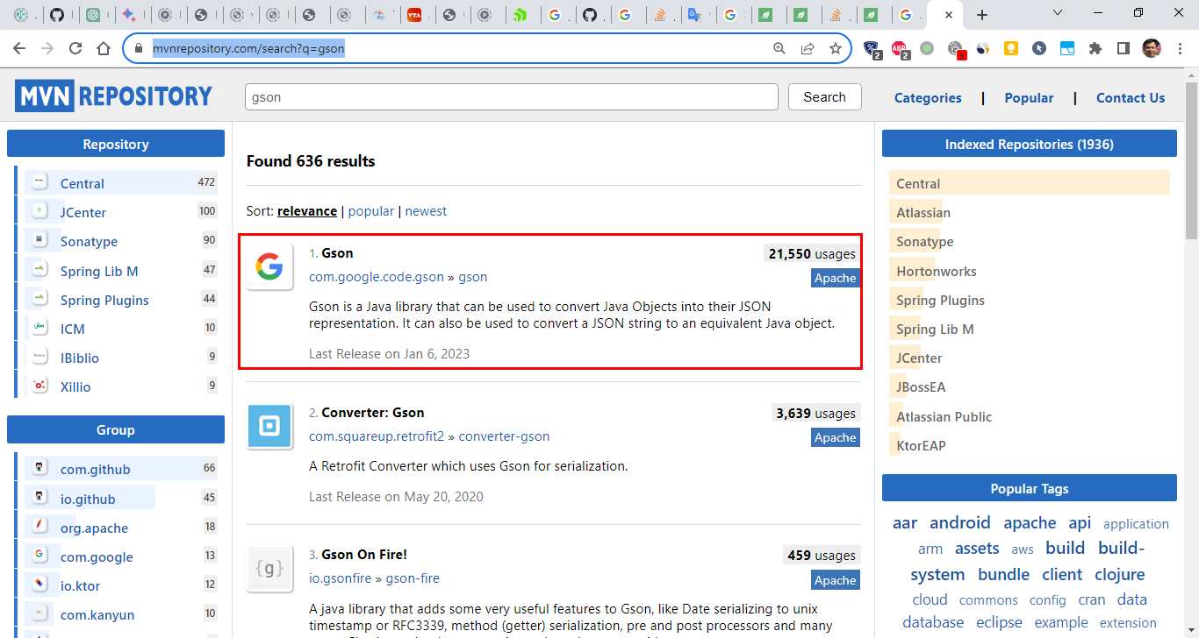

<dependency>  
 <groupId>com.google.code.gson</groupId>  
 <artifactId>gson</artifactId>  
 <version>2.10.1</version>  
</dependency>

